Hamna Qasim
55194
Compiler Construction
Week 8, Lab 7

Task 1:
Code:
#include <iostream>
using namespace std;

string input;
int i = 0;

void S() {
if(input[i] == 'a') {
i++;
S();
if(input[i] == 'b') {
i++;
} else {
cout << "Error\n";
exit(0);
}
}

}

int main() {
cout << "Enter string: ";
cin >> input;
S();

if(i == input.length())
cout << "Accepted\n";
else
cout << "Rejected\n";
}

Output:
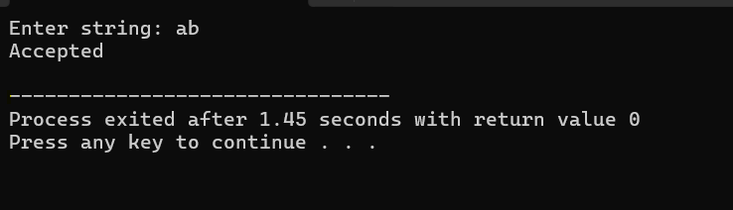

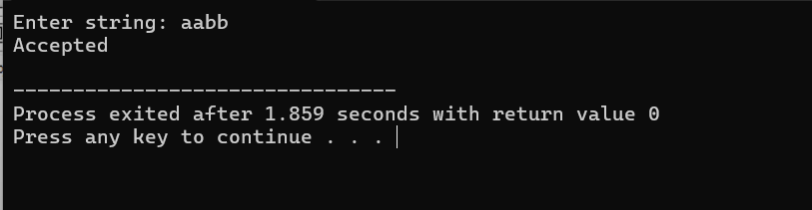

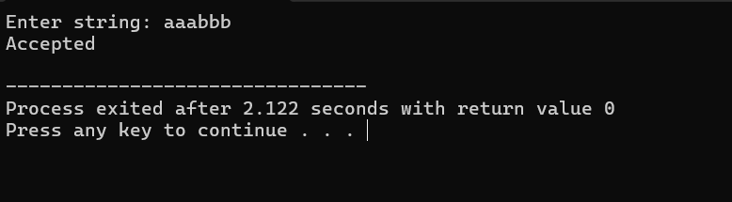

In this task, each a is matched with corresponding b so that only those strings are accepted which have equal number of a’s and b’s.

Task 2:
Convert the following grammar into non-left recursive form:
E → E - T | T
T → T * F | F
F → id | (E)

Left Recursive form:
E = T E'
E' = - T E' | e
T = F T'
T' = * F T' | e
F = i | (E)

Code:
#include <iostream>
using namespace std;

string input;
int i = 0;

void E();
void Eprime();
void T();
void Tprime();
void F();

void match(char c) {
if(input[i] == c)
i++;
else {
cout << "Error\n";
exit(0);
}
}

void E() {
T();
Eprime();
}

void Eprime() {
if(input[i] == '-') {
match('-');
T();
Eprime();
}
}

void T() {
F();
Tprime();
}

void Tprime() {
if(input[i] == '*') {
match('*');
F();
Tprime();
}
}

void F() {
if(input[i] == 'i') {
match('i');
}
else if(input[i] == '(') {
match('(');
E();
match(')');
}
else {
cout << "Error\n";
exit(0);
}
}

int main() {
cout << "Enter expression: ";
cin >> input;

E();

if(i == input.length())
cout << "Accepted\n";
else
cout << "Rejected\n";
}
Output:
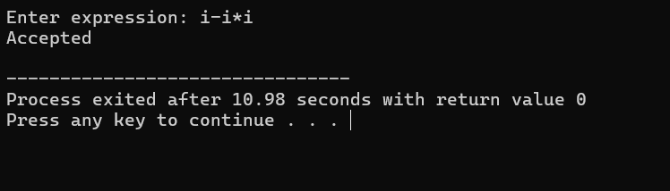

Task 3:
Code:
#include <iostream>
using namespace std;

string input;
int i = 0;

void E();
void Eprime();
void T();
void Tprime();
void F();

void match(char c) {
if(input[i] == c)
i++;
else {
cout << "Error\n";
exit(0);
}
}

void E() {
T();
Eprime();
}

void Eprime() {
if(input[i] == '+' || input[i] == '-') {
char op = input[i];
match(op);
T();
Eprime();
}
}

void T() {
F();
Tprime();
}

void Tprime() {
if(input[i] == '*' || input[i] == '/') {
char op = input[i];
match(op);
F();
Tprime();
}
}

void F() {
if(input[i] == 'i') {
match('i');
}
else if(input[i] == '(') {
match('(');
E();
match(')');
}
else {
cout << "Error\n";
exit(0);
}
}

int main() {
cout << "Enter expression: ";
cin >> input;

E();

if(i == input.length())
cout << "Accepted\n";
else
cout << "Rejected\n";
}
Output:
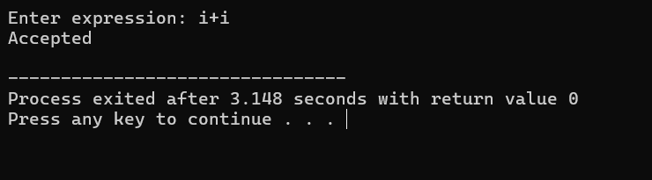

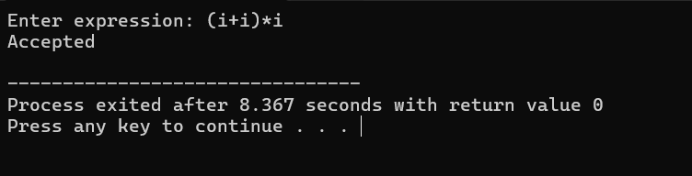

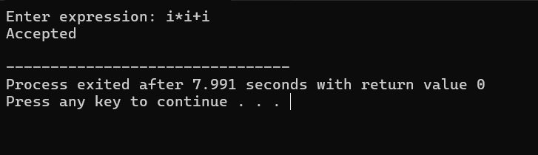

Parsing Steps:
E initiates parsing by calling T first, followed by E' which handles + and -, while T handles * and /.
Basic operands (id or (E)) match F.
The expression is processed step-by-step by recursion. • The order of operators is preserved: *, / before +, -
If an expression fully complies with grammar, it is accepted.

